**Updated:**

**Approve.java**

**Prevent spam on display button**

**Update csv function(Approve record)**

**Registerform.java**

**Prompt user if name or id already exist.**

**Bug Founded:**

**Display button can spam on multiple page**

**User login checking is broken**

**Manage.java failed to set radio button when select user**

**Your life**

**Etc….**

**Registerform.java**

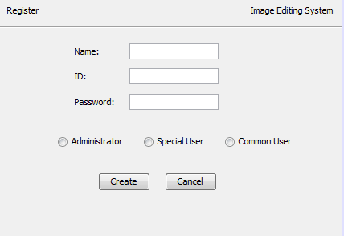



**(user account 儲存係user.csv)**

**希望整到以下功能：**

**檢查Name和ID是否重複**

**重複就唔俾創**

**update.java**

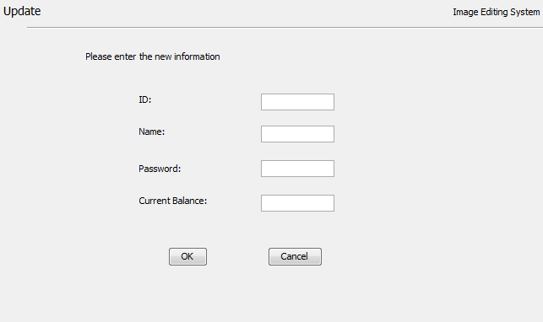

**唔識update user.csv**

**Manage.java**

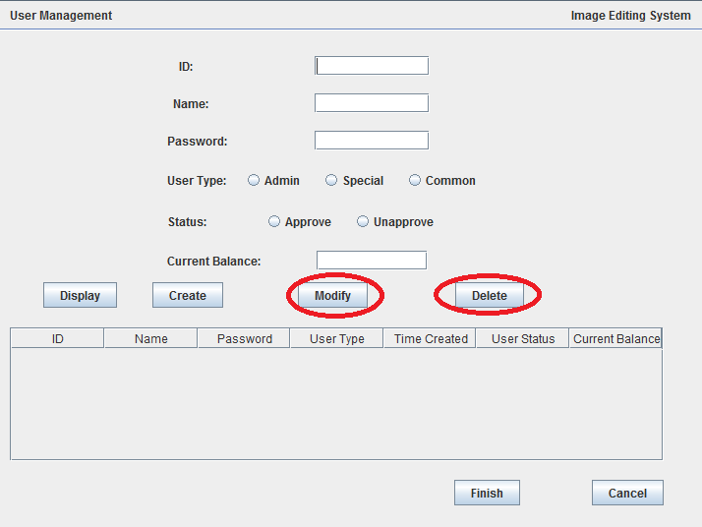

**唔識update user.csv**

**ARecordManage.java**

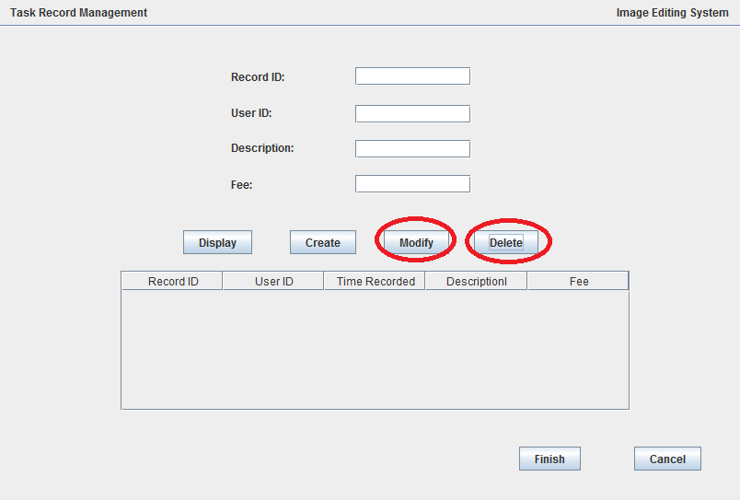

**唔識update user.csv**

**Approve.java**

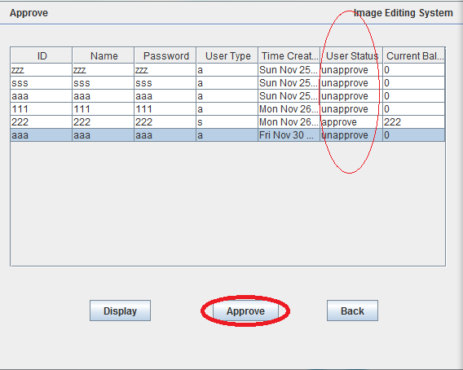

**希望整到以下功能：**

**選中的ac如果係unapprove，禁左Approve之後，unapprove改做approve**

**user.csv都會同步改**